Chief Officer for Childrens Services

Room 140 County Hall
Topsham Road
Exeter
EX2 4QD

Tel: 01392 381093
Email: jo.olsson@devon.gov.uk

9th January 2016

Dear colleague,

I am writing to make you aware of some important changes to both the tools for supporting good practice in Early Help assessment and planning, currently known as the DAF, and to the electronic system for sharing information between partners (Holistix).

Collectively we can make a real difference to the lives of children and young people by strengthening the multi- agency Early Help Offer to children, young people and their families, and reducing the need for unnecessary statutory intervention. The tools and electronic system should act as enablers of good multi agency practice. The Alliance Executive recognises the need for both the tools and the system, but is aware of feedback from the front line that current tools don’t enable good practice.

In response to this feedback, practitioners from a range of frontline services, and the system provider, have been involved in a revision of the tools and an upgrade to the system. There has been positive feedback on both, so now is the time to begin the implementation process.

‘Switchover’ from the existing Holistix system to the upgraded one ‘Right for Children’ will take place on April 10th.

Outlined below is the timescale of activity to support the change.

January

User Acceptance testing

This brings together the tools and system so that both can be tested ‘live’ and any final changes made before the switchover on 10 April.

It is critical for the strengthening of the Multi Agency Early Help Offer that all Alliance partners engage in the multi agency team around the family approach and identify practitioners from their organisation who will take a lead professional role.

Representatives of these practitioner groups will be involved in the user acceptance testing period.

February/March

A series of multi agency training workshops, in preparation for switchover. They will be delivered locally. The intention from this activity is to build a confident and capable workforce in localities and develop ‘a local expert group’.

There will be two separate strands to the learning activity:

A focus on practice – for frontline practitioners (particularly lead professionals) and managers. These will be delivered through existing early Help Practitioner forums.

A focus on Systems - for those in organisations with an IT/Business admin function with a practice ‘buddy’. This is to enable admin staff to be appropriately skilled to support practitioners in using the IT system.

You will receive notification of all of these events through Alliance communications and then sign up will be through the DSCB website .

Please address any queries to Philippa Court, Senior Officer for Early Help
Philippa.court@devon.gov.uk or tel 01392 383000, and when prompted ask for Philippa Court.

Yours Sincerely

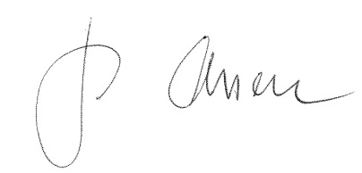

Jo Olsson
Chief Officer for Childrens Services

