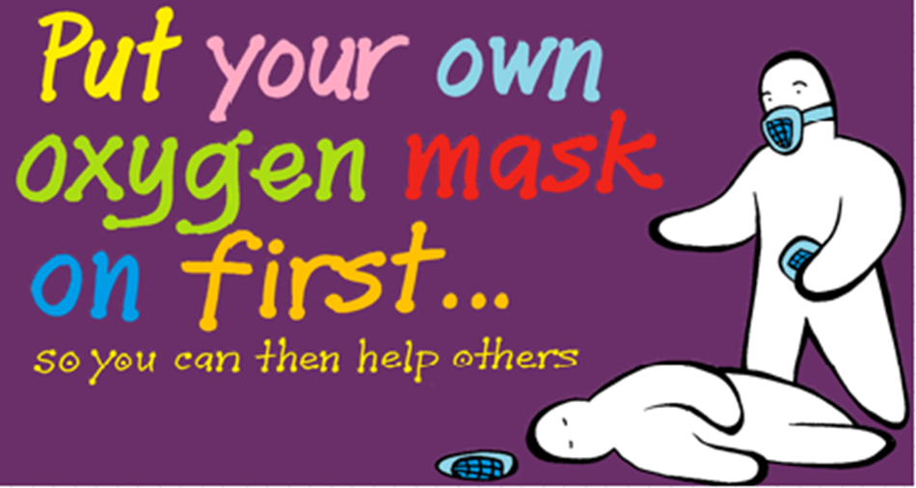
PIP WILSON, creator of blob tree/blob people
‘is one of the most energetic and engaging trainers I have seen’
Saturday 16th September 2017, 10am to 4pm at Ocean, Queens Drive, Exmouth, EX8 2AY
Lunch and refreshments provided.
Cost: £60
£30 (Balloons staff and Balloons volunteers)
Payment by cheque or BACS.
To book or any enquiries, email Liz Cook at lizmmcook@gmail.com
An experiential day of raising awareness and developing skills with a view to becoming more able to enter and retain helping relationships in our professional and private lives. It will be beyond ‘well-being’ – more about ‘well-doing’ and ‘whole-becoming’.
WHERE TO PARK
- Really, really close by
- Esplanade on Street parking, Devon County Council, EX8 2AY
- A little walk away
- Queens Drive Car Park, East Devon District Council Pay and Display, EX8 2AY
- A bit more of a walk away
- Maer Road Car park, East Devon District Council, Pay and Display, EX8 2DB
All Proceeds going to Balloons (after expenses)
Registered Charity Number 1158666

